**PAI LAB 1**

**Task 1:**

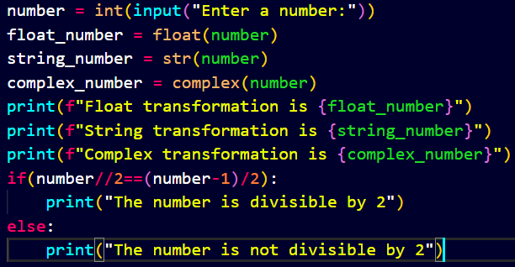

**Output:**

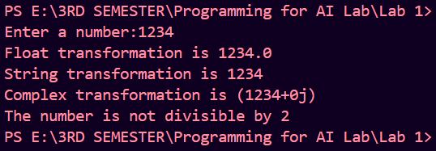

**Task 2:**

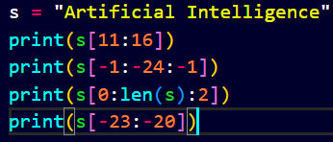

**Output:**

**Task 3:**

**Output:**

**Task 4:**

**Output:**

**Task 5:**

**Output:**

